MEDSLIK-II v3.01

consistency tests

# foreword

Almost a year has passed since we started developing OKEANOS based on the WITOIL oil spill forecasting system. Since then, hundreds of oil spill simulations have been performed using MEDSLIK-II at almost every part of the ice-free ocean and at different spatial resolutions. A unique dataset of spill observations, sometimes sequential observations of the same spill, was used to validate our model results. MEDSLIK-II was also used in forecasting exercises (e.g. CEDRE-France). Errors and inconsistencies, as expected, popped up and were addressed accordingly.

Our following natural step is sharing the most up-to-date model version with the MEDSLIK-II community. Prior to the model release, a thorough code cleanup and consistency check were performed. The clean code was compared to the currently operational and debugged MEDSLIK-II running on WITOIL. All random values used in MEDSLIK-II programs were set to a fixed value (0.5) to eliminate uncertainties in the consistency check results.

# core changes

1. the concept of “region” was removed from the code. “region” variable is no longer used since MEDSLIK 2.0. . All references to the region variable, IF loops, and user input requirements associated to them were removed.
2. variables *icurrents* and *iwinds*, current and wind fields identifiers (e.g. ERA, SKIRON, ADRIFS, etc), were removed since MEDSLIK-II no longer accepts diversely structured dataset. All references to such variables, IF loops, and user input requirements associated to them were removed.
3. Unused subroutines were removed, namely:

* climatem: computes climatological SST at location of spill temperature taken is for the nearest data point to spill updated every step
* climawind: read climatological wind and interpolate to medslik grid interpolation based on inverse distance to nearest 5 data points on first step compute increments then update every step compute wind velocity & direction at centre of spill
* mfswind: constructs wind speed & direction used for 24- or 6-hour average forecast wind used to forecast MOM/CYCOM/ADRICOSM currents. The wind velocity wx,wy have already been read in subroutine fcstcur
* userwind: read file 'medslik.wnd' in case iwind = 8
* climacurr: read climatological currents specified on the medslik grid on first step compute increments then update every step
* season: computes season of the year for a given julian date (<=365)
* setunifcurr: eads water current speed and direction from file medslik.crr for spatially uniform, user-defined currents - icurrents = 8.
* fcstcur: constructs current field in case of daily forecast data
* readfcst: read daily forecast current data and interpolate to Medslik grid

# running the Lebanon case study

|  |  |
| --- | --- |
| MEDSLIK 3.0 | MEDSLIK 3.01 |
|  |  |
|  |  |
|  |  |
|  |  |
|  |  |
|  |  |
|  |  |

|  |  |
| --- | --- |
| MEDSLIK 3.0 | MEDSLIK 3.01 |
|  |  |
|  |  |
|  |  |
|  |  |
|  |  |
|  |  |
|  |  |

# test simulation

sim_length=0096 # choose the simulation length (in hours, 4 characters)

date=01/07/2021 08:00

lat_degree=-31

lat_minutes=-52.45

lon_degree=-51

lon_minutes=-44.66

duration=0072 # spill duration, in hours, 4 characters, if the spill is instantaneous type 0000

spillrate=01000.00 # spill rate in tons/hours, if the spill is instantaneous write the total tons spilled

OIL_API=28

# average spill displacement

control



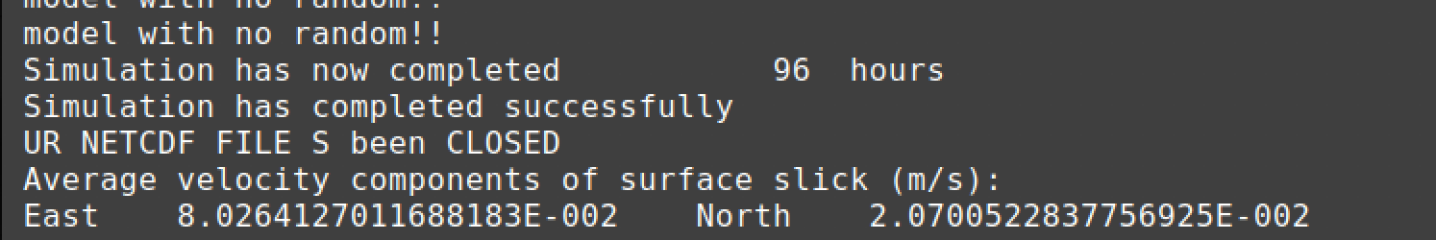clean version

# surface oil concentration

|  |  |
| --- | --- |
|  |  |
|  |  |
|  |  |
|  |  |

# beached oil concentrations

|  |  |
| --- | --- |
|  |  |
|  |  |
|  |  |
|  |  |

# center of mass tseries

The spill center of mass was calculated for both simulations (i.e. generated by the control and clean codes) and printed onto a txt file. The two files were compared with the diffchecker application and resulted identical.

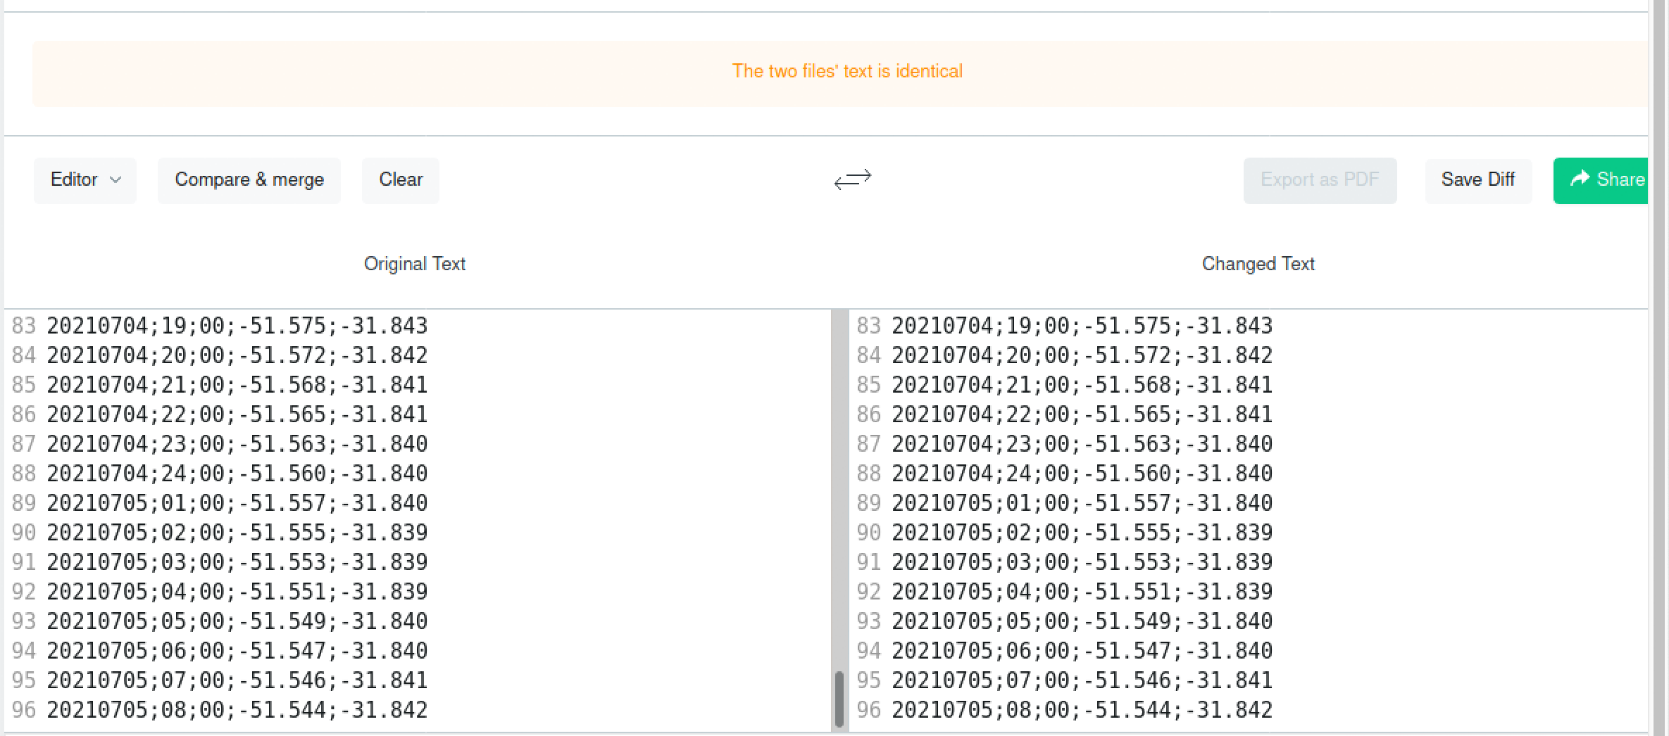

# oil weathering

The oil weathering file, medslik.fte, for both simulations (i.e. generated by the control and clean codes) were compared with the diffchecker application and resulted identical.

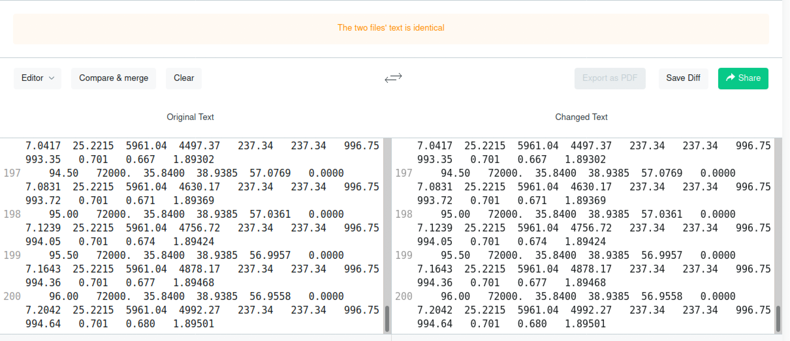

# execution time

Control experiment:

2021-07-12 10:37:06 1626079026 mdk start EXE

2021-07-12 10:37:31 1626079051 mdk end EXE - Execution time: 24.425968563 sec.

Clean code experiment:

2021-07-12 10:46:55 1626079615 mdk start EXE

2021-07-12 10:47:19 1626079639 mdk end EXE - Execution time: 23.632186380 sec.